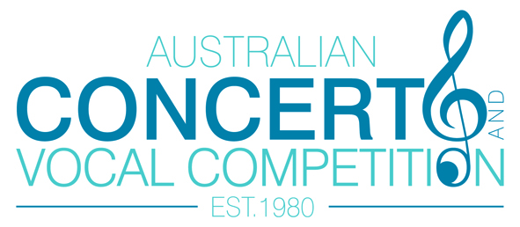
2015 Australian Concerto & Vocal Competition Launch
Competition Director’s Notes:

The renewal of 3 year TCC Partnership Grant has assured the competition can continue to grow and expand and also includes access to the city’s premier venue, the Townsville Civic Theatre for the next 3 years. The venue allows much greater rehearsal and preparation space for the management and entrants given the hectic nature of the running of the event, with rehearsals, followed by ‘warm-up’, followed by performance on a revolving cycle for each session.
We trust that this will also have a flow on effect of attracting larger audience numbers for this event, one that is quite unique for a regional centre and has a significant prestige as a national event.
Last year saw the inaugural Open Vocal Section which attracted a huge response from around Australia and overseas, and this year this section will now have a Preliminary Stage as does the Open Instrumental Section, from which three finalists will be chosen to perform at a Finals Concert. The Open Vocal Finals will be held on Sunday 26th July @ 2pm and the Open Instrumental Finals will conclude the event on Tues 28th July @ 7.30pm.
We look forward to welcoming two adjudicators of international standing, Ms Cheryl Barker, one of Australia’s leading operatic sopranos, and Mr Carl Pini, originally from London, now residing in Sydney after a career encompassing a number of roles in places such as Hong Kong and New Zealand.
We welcome the return of two of our resident official accompanists, Rhodri Clarke (Melbourne), and Maryleigh Hand (Sydney) and newcomer, Ms Prue Gibbs from Brisbane. These wonderful artists take on the huge task of representing the orchestra that accompanies soloists performing works from the concerto and operatic repertoire.
We have been shown great support from the local community in sponsoring prize money for this prestigious event and I would like to make special mention of NQ Employment for covering the new Open Vocal Section and for Roy & Margery Jorgensen for covering the continuing vocal section. We hope in time for the vocalists to rival the instrumentalists.
The continuing support from Mr Graham Jackson of Loloma and Mr John Doolan of Parry NQ formerly Parry Nissan, long time sponsors of this event and the many individuals and local arts organisations assist in making valuable contributions to the total prize money.

There is a continuing support for local school age musicians in the provision of two specific school age sections and a significant addition to the prizes available is a specific prize the Youth Development Award, jointly sponsored by donations from Mrs Dinie Gaemers, Arties Music Store and the Australian Festival of Chamber Music.
Local musicians are encouraged to participate through special encouragement awards sponsored by Arties Music and Mrs Dinie Gaemers also sponsors the award for the Most Outstanding Musician from North Queensland.
Local North Queensland musicians and singers have long been recognized in past competitions and have gone on to make worthwhile careers in music, these include singer Peter Axford from the Tablelands, Graeme Jennings (violinist) USA & Australia, Brendan Joyce, director of the Camerata of St Johns, who now take part in the Australian Festival of Chamber Music, and David Dalseno from Townsville who is a member of the ensemble to mention a few.

